21-MAR-2022

* Kubernetes Architecture
* To create boot strap server in AWS console
* Install packages - kuberctl, kops and awscli
* To create IAM role with required permissions and attach to boot strap server
* Deploy Kubernetes Cluster
* Creation of pods
* Deletion of cluster

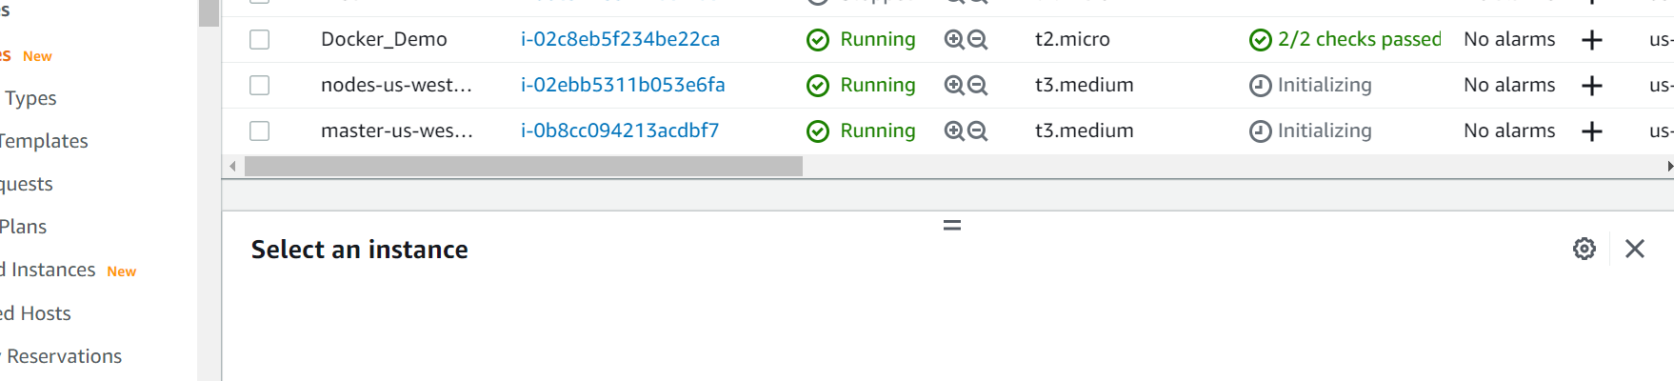

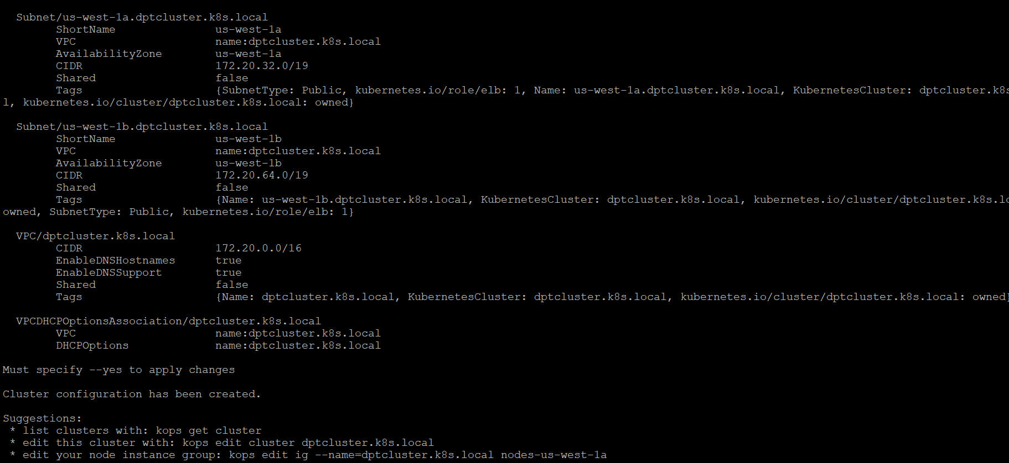

22-MAR-2022

* Kubernetes
* Kubernetes pod creation
* Kubernetes replica set deployment
* To create bootstrap in AWS console
* Deploy Kubernetes cluster
* To create manifesto for deployment controller and run it
* Deployment status check of replica set and pod.

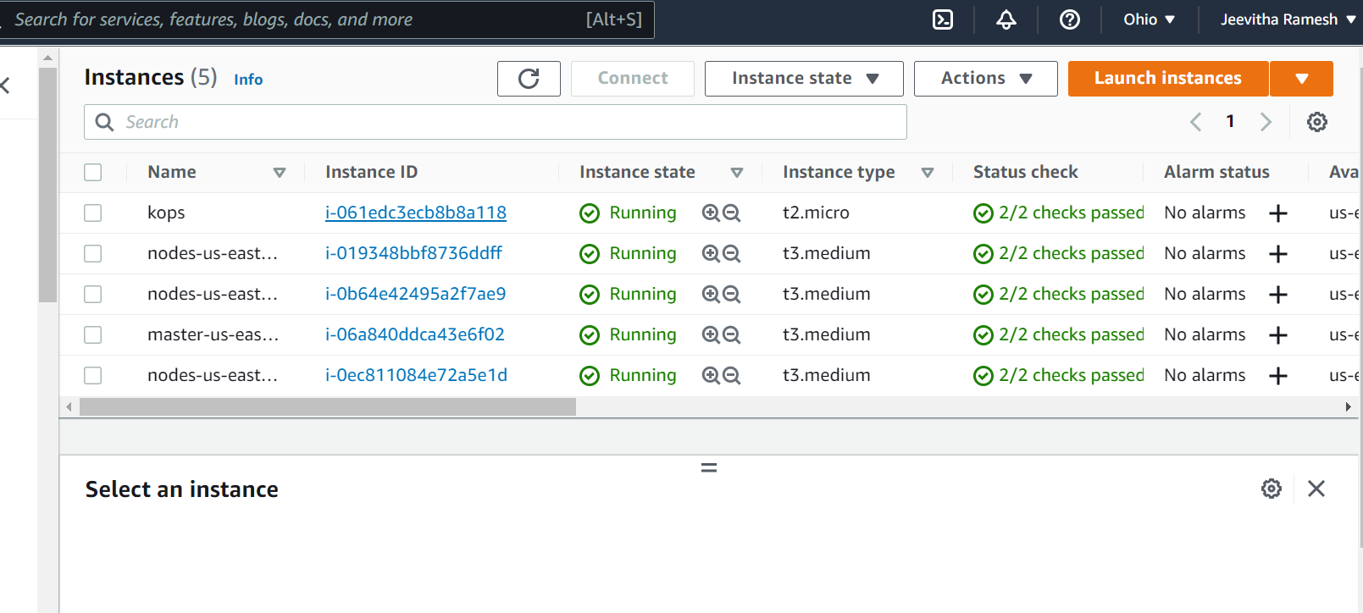

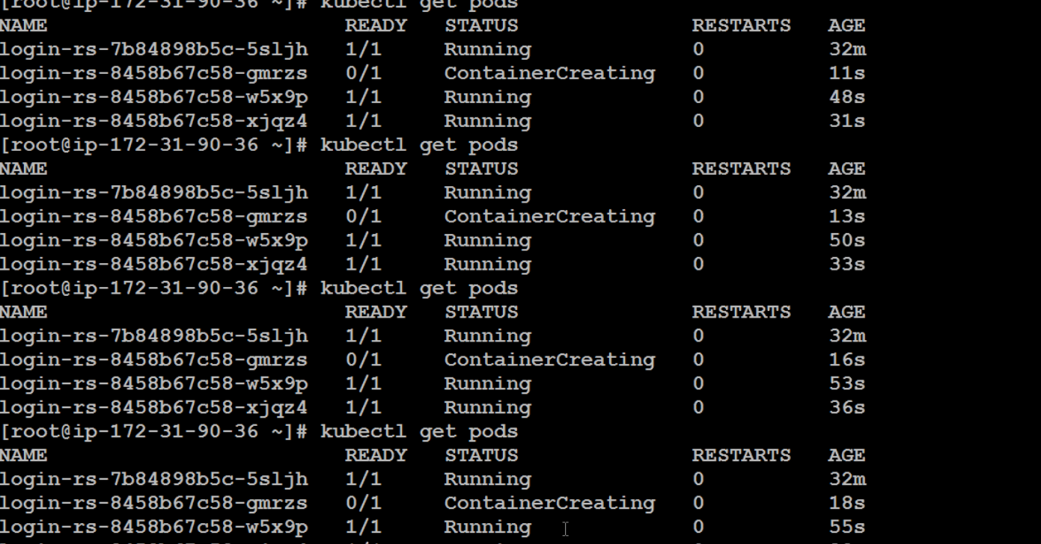

23-MAR-2022

* Cluster IP
* AWS load balancer
* Readiness check and namespace
* Deploy Kubernetes cluster
* Install packages kubectl, kops & awscli
* To create manifesto for deployment of load balancer
* To run the manifesto and check the deployment status of load balancer with worker nodes.

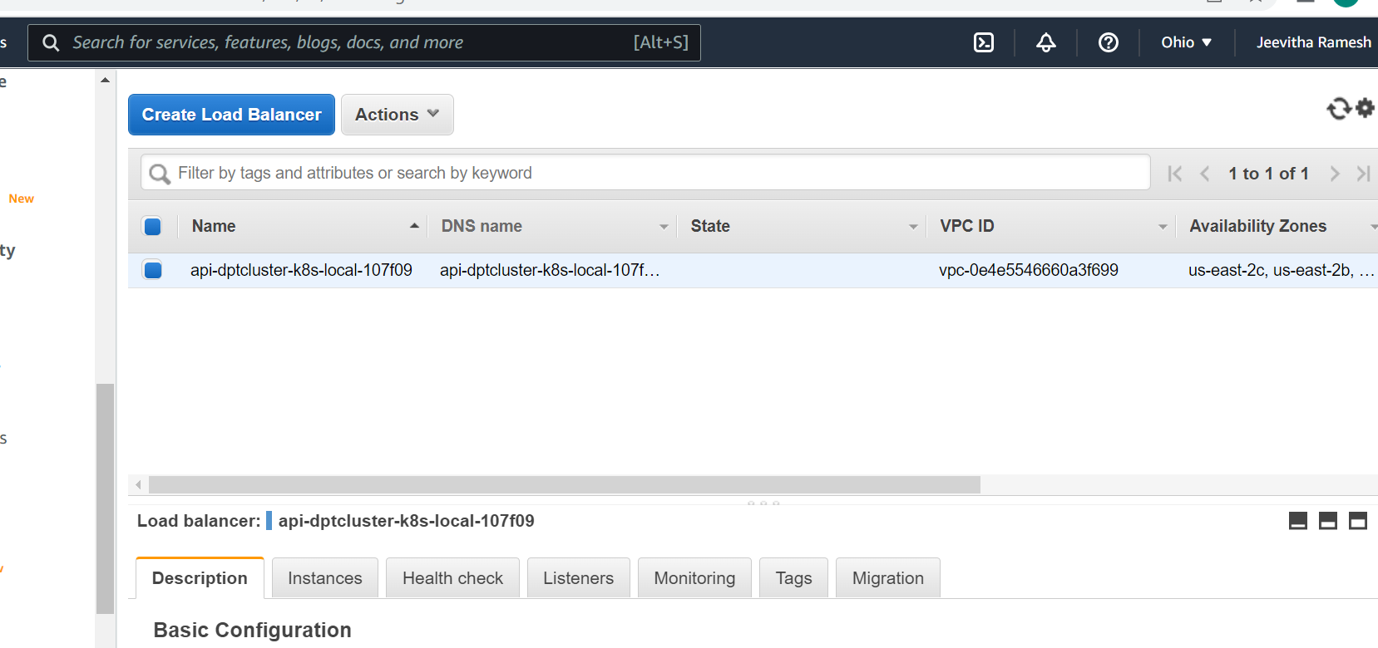

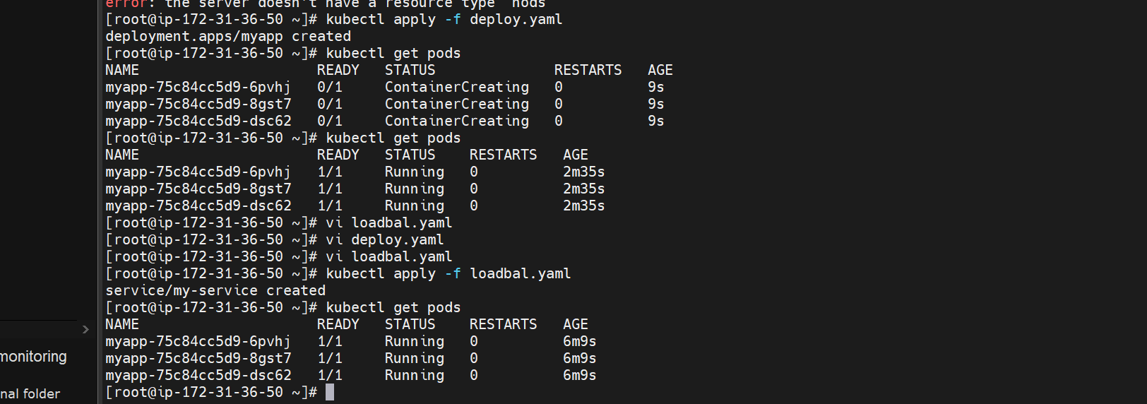

24-MAR-2022

* Azure
* To create Azure free tier account
* To create Linux machine and configure
* Geography Vs Region Vs AZ
* Disk
* Resource groups
* Subscriptions
* Azure Hierarchy

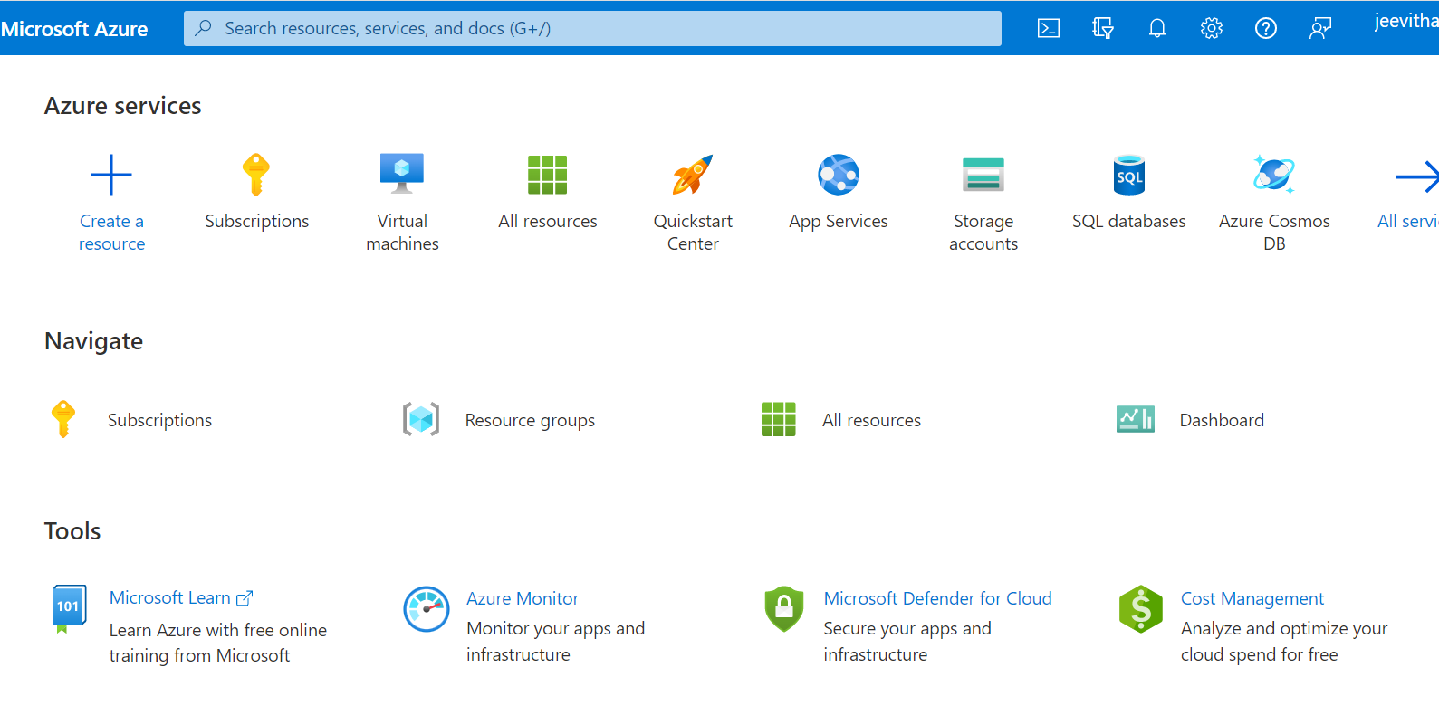

25-MAR-2022

